**BUS RESERVATION SYSTEM**

**EXPERIMENT-9**

**To draw the behavioural view diagram: State-chart diagram, Activity diagram.**

# State-chart Diagram

A state-chart diagram for a Bus reservation system demonstrates the different states the system can be in and the transitions between these states.

**States and Transitions:**

1. **User Initiates Request:** The initial state when a user starts using the bus reservation system .
   * **Transition:** User Inputs Details -> Details Entered
2. **Details Entered:** The state where the user has provided necessary details like origin, destination, and time.
   * **Transition:** Search for Buses -> Buses Searched
3. **Buses Searched:** After the system searches for available buses based on user input.
   * **Transition:** Display Search Results -> Results Displayed
4. **Results Displayed:** When the system displays the search results to the user.
   * **Transition:** User Selects Bus -> Bus Selected
5. **Bus Selected:** The state where the user selects a specific bus.
   * **Transition:** Reserve Seat -> Seat Reserved
6. **Seat Reserved:** After the user has reserved a seat on the selected bus.
   * **Transition:** Confirm Reservation -> Reservation Confirmed
7. **Reservation Confirmed:** The final state where the reservation is successfully confirmed.
   * **Transition:** Notify User -> User Notified
8. **User Notified:** The state where the user is notified about the reservation confirmation. This is the final state of the process

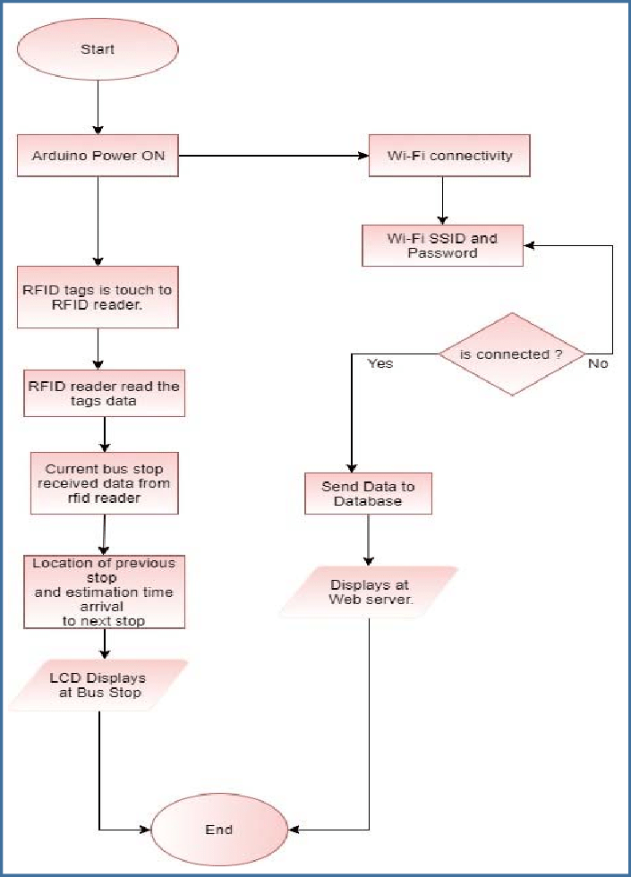

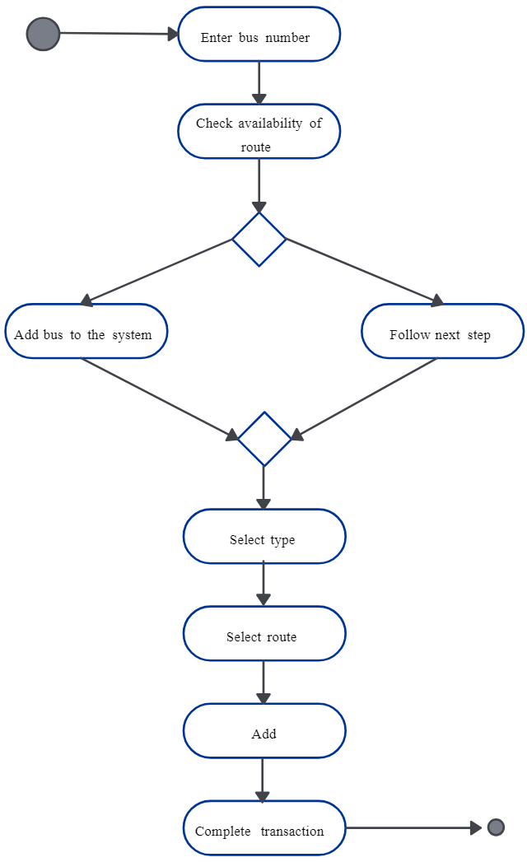

# Activity Diagram